**WEEK – 6**

**React**

**1.Creating 1st react project**

**App.js**

import React from 'react';

function App() {

  return (

    <h1 style={{ textAlign: 'center' }}>

      Created my first react project

    </h1>

  );

}

export default App;

**Output:**

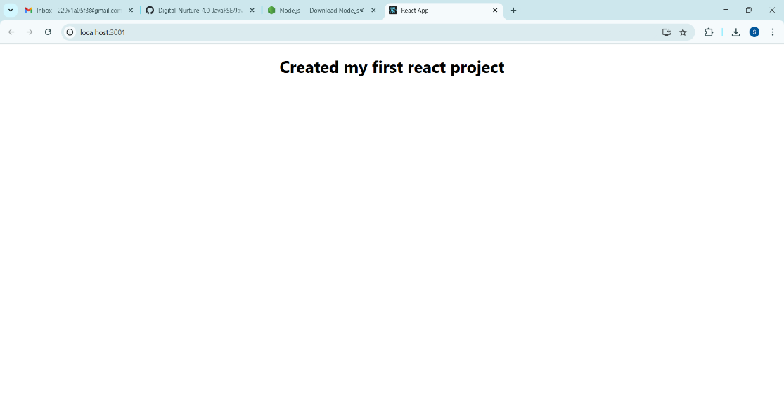

**2. Creating StudentApp react project**

**About.js**

import React, { Component } from "react";

class About extends Component {

  render() {

    return (

      <div>

        <h1>Welcome to About Page of Student Management Portal</h1>

      </div>

    );  }}

export default About;

**Contact.js**

import React, { Component } from "react";

class Contact extends Component {

  render() {

    return (

      <div>

        <h1>Welcome to Contact Page of Student Management Portal</h1>

      </div>

    );  }}export default Contact;

**Home.js**

import React, { Component } from "react";

class Home extends Component {

  render() {

    return (

      <div>

        <h1>Welcome to Home Page of Student Management Portal</h1>

      </div>

    );  }}export default Home;

**App.js**

import logo from './logo.svg';

import './App.css';

import Home from './Components/Home';

import About from './Components/About';

import Contact from './Components/Contact';

function App()

{

  return(

    <div className="container">

      <Home/>

      <About/>

      <Contact/>

    </div>  );}export default App;

**Output:**

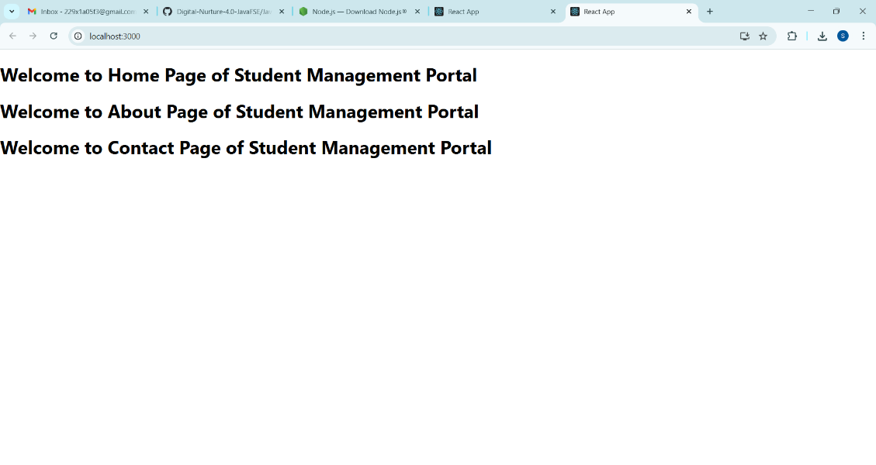

**3.Creating score calculator app**

**CalculateScore.js**

import React from 'react';

import '../Stylesheets/mystyle.css';

function CalculateScore(props) {

  const average = (props.total / props.goal).toFixed(2);

  return (

    <div className="score-container">

      <h2>Student Score Details</h2>

      <p><strong>Name:</strong> {props.name}</p>

      <p><strong>School:</strong> {props.school}</p>

      <p><strong>Total Marks:</strong> {props.total}</p>

      <p><strong>Goal:</strong> {props.goal}</p>

      <p><strong>Average Score:</strong> {average}</p>

    </div>

  );

}export default CalculateScore;

**mystyle.css**

.score-container {

  text-align: center;

  background-color: #f0f8ff;

  padding: 20px;

  margin: 30px auto;

  border: 2px solid #4CAF50;

  width: 50%;

  border-radius: 10px;

  box-shadow: 0 4px 8px rgba(0, 0, 0, 0.1);

}.score-container h2 {  color: #4CAF50;}

**App.js**

import React from 'react';

import CalculateScore from './Components/CalculateScore';

function App() {

  return (

    <div className="App">

      <CalculateScore

        name="Alisha Anjum"

        school="G. Pulla Reddy Engineering College"

        total={450}

        goal={5}

      />

    </div>

  );

}

export default App;

**Output:**

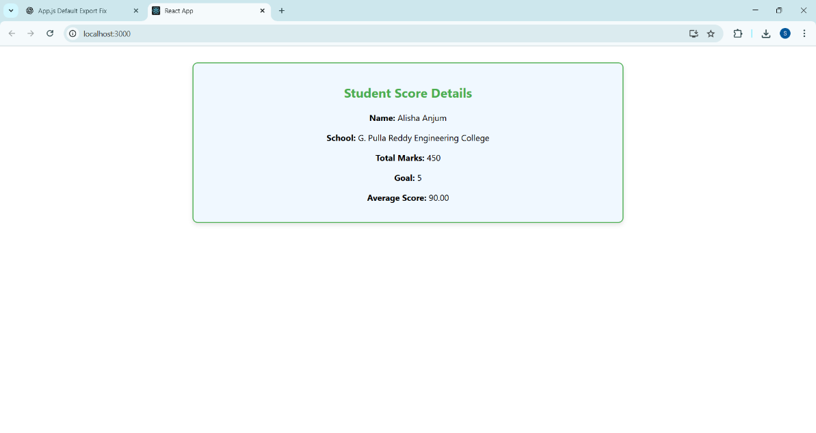

**4.Blog app**

**Post.js**

import React from 'react';

function Post(props) {

  return (

    <div style={{ border: "1px solid #ccc", margin: "10px", padding: "10px" }}>

      <h3>{props.title}</h3>

      <p>{props.body}</p>

    </div>

  );

}

export default Post;

**Posts.js**

import React, { Component } from 'react';

import Post from './Post';

class Posts extends Component {

  constructor(props) {

    super(props);

    this.state = {

      posts: [],

      error: null

    };

  }

  loadPosts = () => {

    fetch('https://jsonplaceholder.typicode.com/posts')

      .then(response => response.json())

      .then(data => this.setState({ posts: data }))

      .catch(err => this.setState({ error: err }));

  }

  componentDidMount() {

    this.loadPosts();

  }

  componentDidCatch(error, info) {

    alert("An error occurred: " + error.toString());

  }

  render() {

    return (

      <div>

        <h2>Blog Posts</h2>

        {this.state.posts.map(post => (

          <Post key={post.id} title={post.title} body={post.body} />

        ))}

      </div>

    );

  }

}

export default Posts;

**App.js**

import React from 'react';

import Posts from './Components/Posts';

function App() {

  return (

    <div className="App">

      <h1>Welcome to Blog App</h1>

      <Posts />

    </div>

  );

}

export default App;

**Output:**

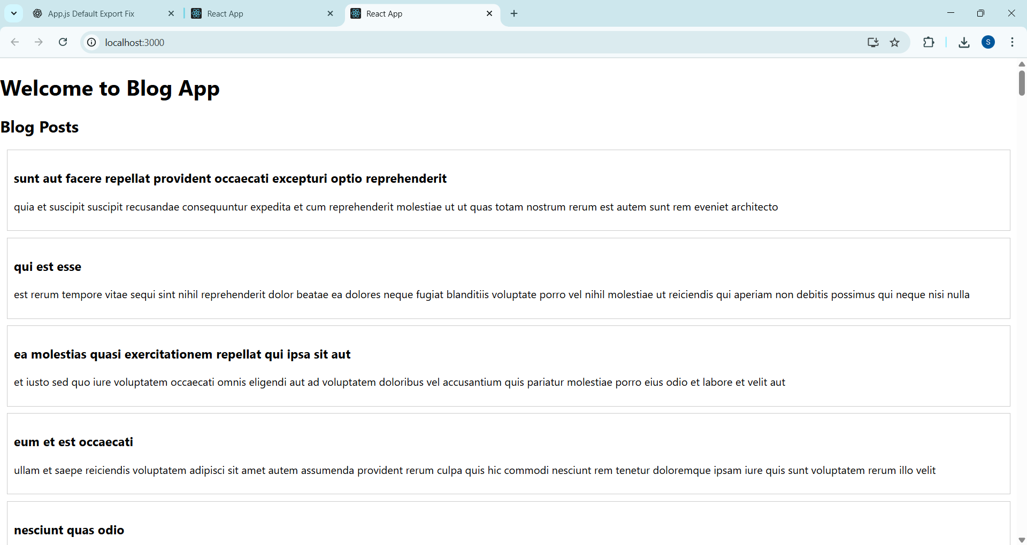

**5. Cohort Dashboard**

**CohortDetails.js**

import React from 'react';

import styles from './CohortDetails.module.css';

function CohortDetails({ name, status, startDate, endDate }) {

  const titleStyle = {

    color: status.toLowerCase() === 'ongoing' ? 'green' : 'blue'

  };

  return (

    <div className={styles.box}>

      <h3 style={titleStyle}>{name}</h3>

      <dl>

        <dt>Status:</dt>

        <dd>{status}</dd>

        <dt>Start Date:</dt>

        <dd>{startDate}</dd>

        <dt>End Date:</dt>

        <dd>{endDate}</dd>

      </dl>

    </div>

  );

}

export default CohortDetails;

**CohortDetails.module.css**

.box {

  width: 300px;

  display: inline-block;

  margin: 10px;

  padding: 10px 20px;

  border: 1px solid black;

  border-radius: 10px;

  background-color: #f9f9f9;

}

dt {

  font-weight: 500;

}

**App.js**

import React from 'react';

import CohortDetails from './Components/CohortDetails';

function App() {

  return (

    <div className="App">

      <h1>My Academy Cohort Dashboard</h1>

      <CohortDetails

        name="React Fundamentals"

        status="Ongoing"

        startDate="2025-07-01"

        endDate="2025-08-15"

      />

      <CohortDetails

        name="Spring Boot Essentials"

        status="Completed"

        startDate="2025-06-01"

        endDate="2025-07-10"

      />

    </div>

  );

}

export default App;

**Output:**

